**Batch Name : SAP ABAP HANA** **DAY-12 ASSIGNMENT**

**EMPLOYEE ID – 46255492** **DATE : 17th OCTOBER, 2022**

Q-1. Demonstrate a case to Design the Adobe form to display the Flight Booking details.

                     Use Tables : SFLIGHT, SPFLI, SBOOK.

**OUTPUT:**

**Creating interface for Adobeform:**

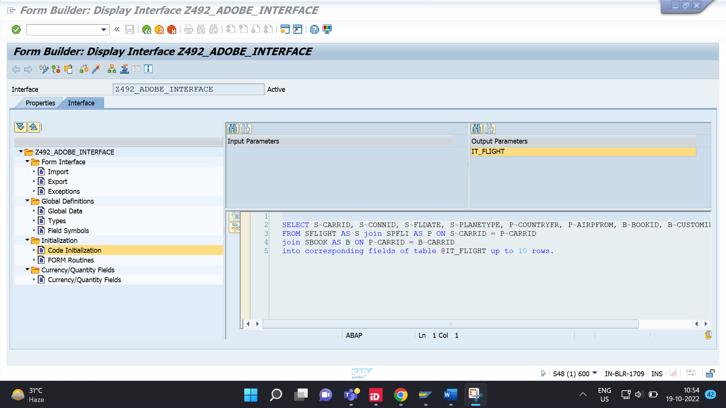

**Designing Adobe Form:**

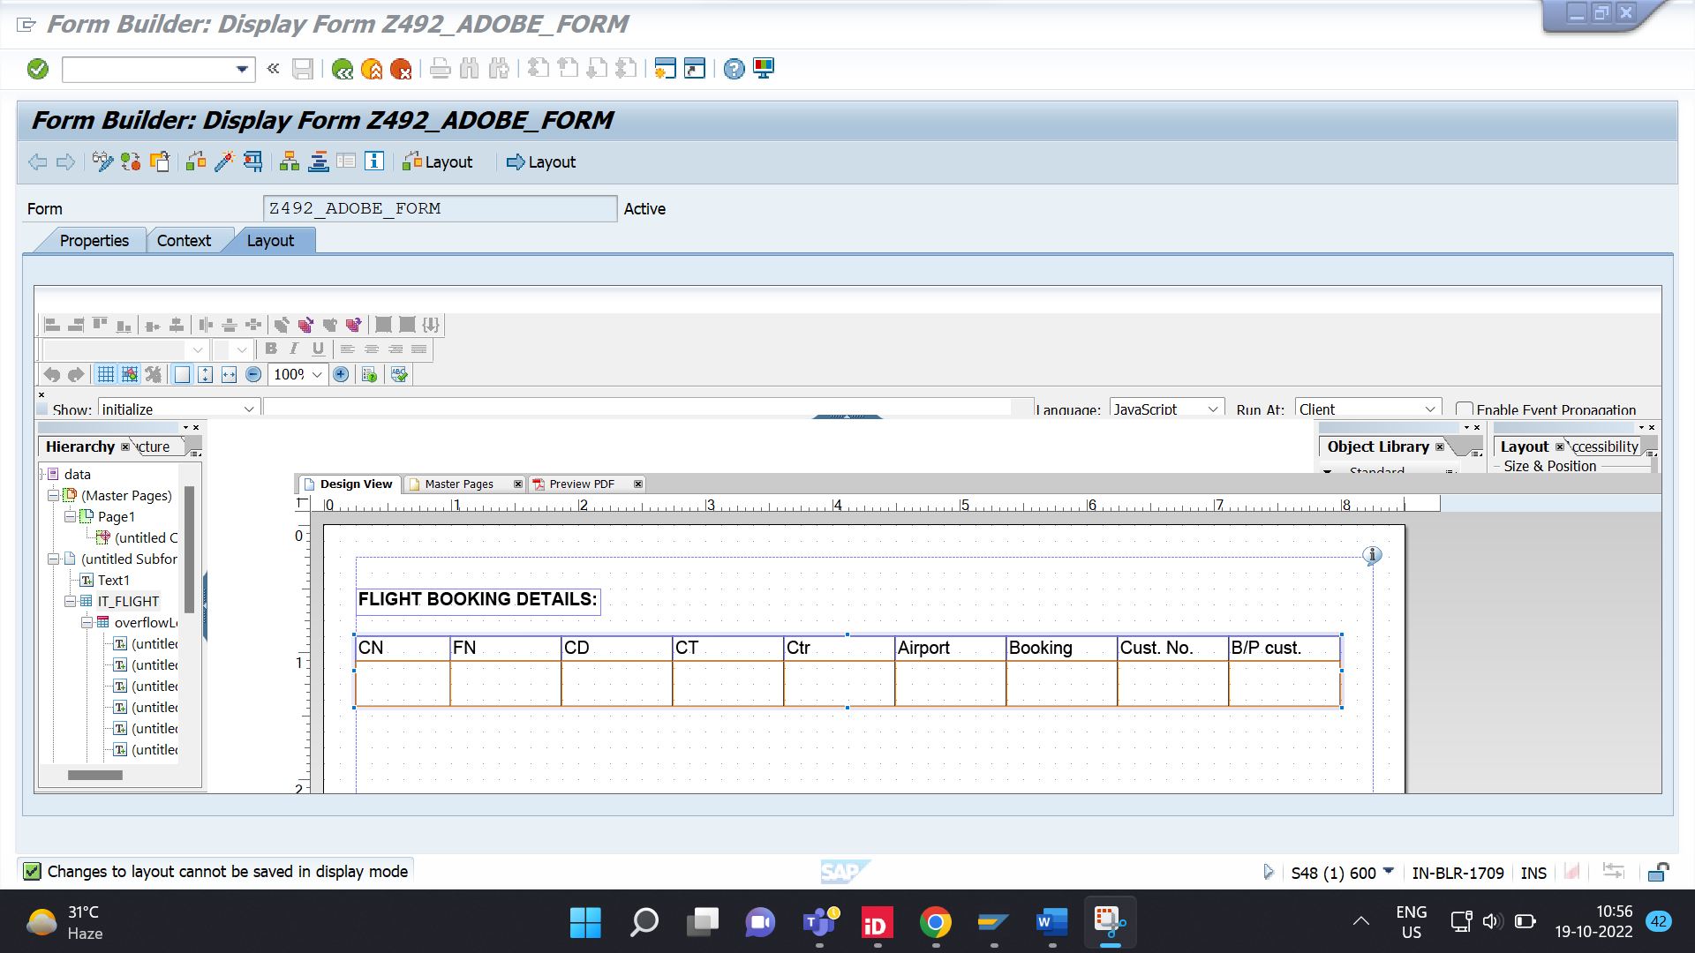

**Displaying Data:**

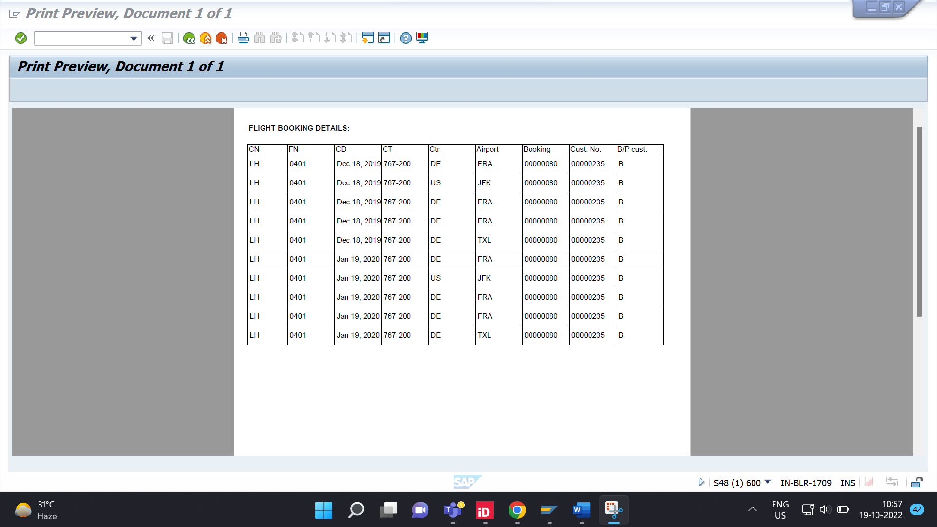

Q-4. Demonstrate a case to use Dynamic TEXT in adobe forms.

**OUTPUT:**

INITIALIZATION:

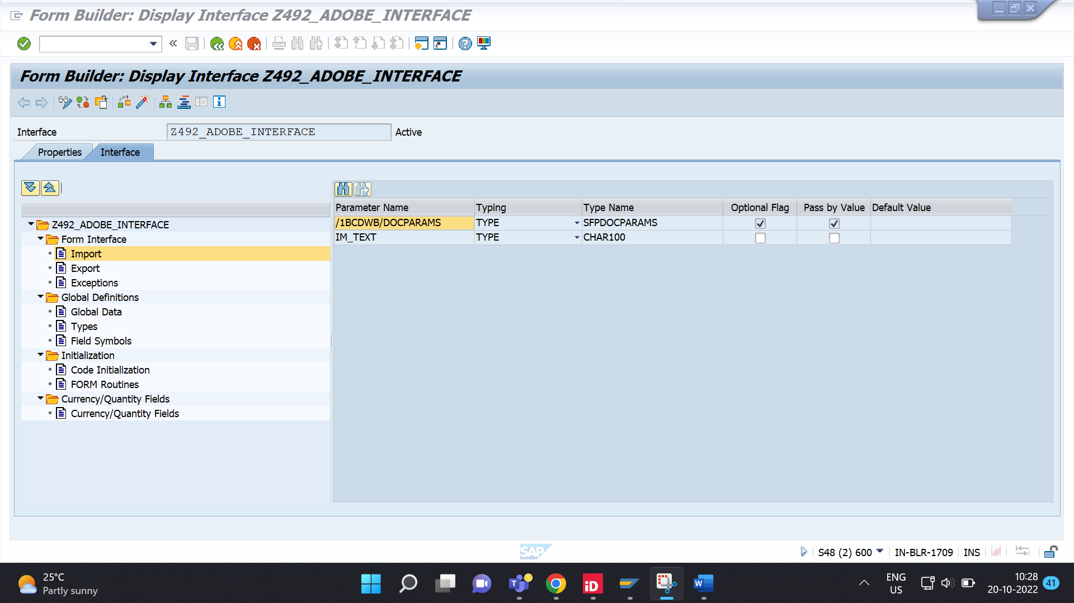

WRITING TEXT:

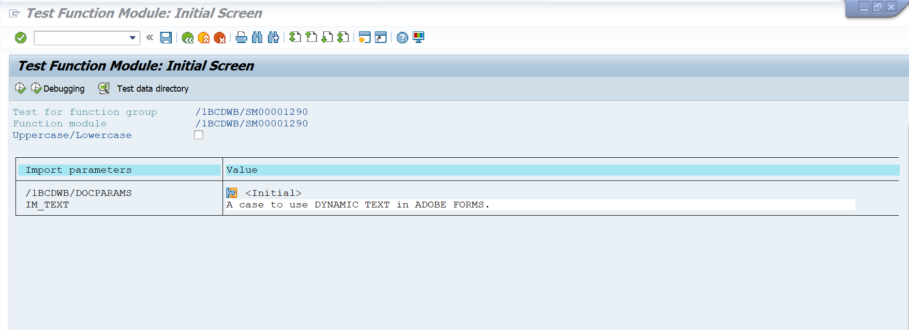

Text printing in single line:

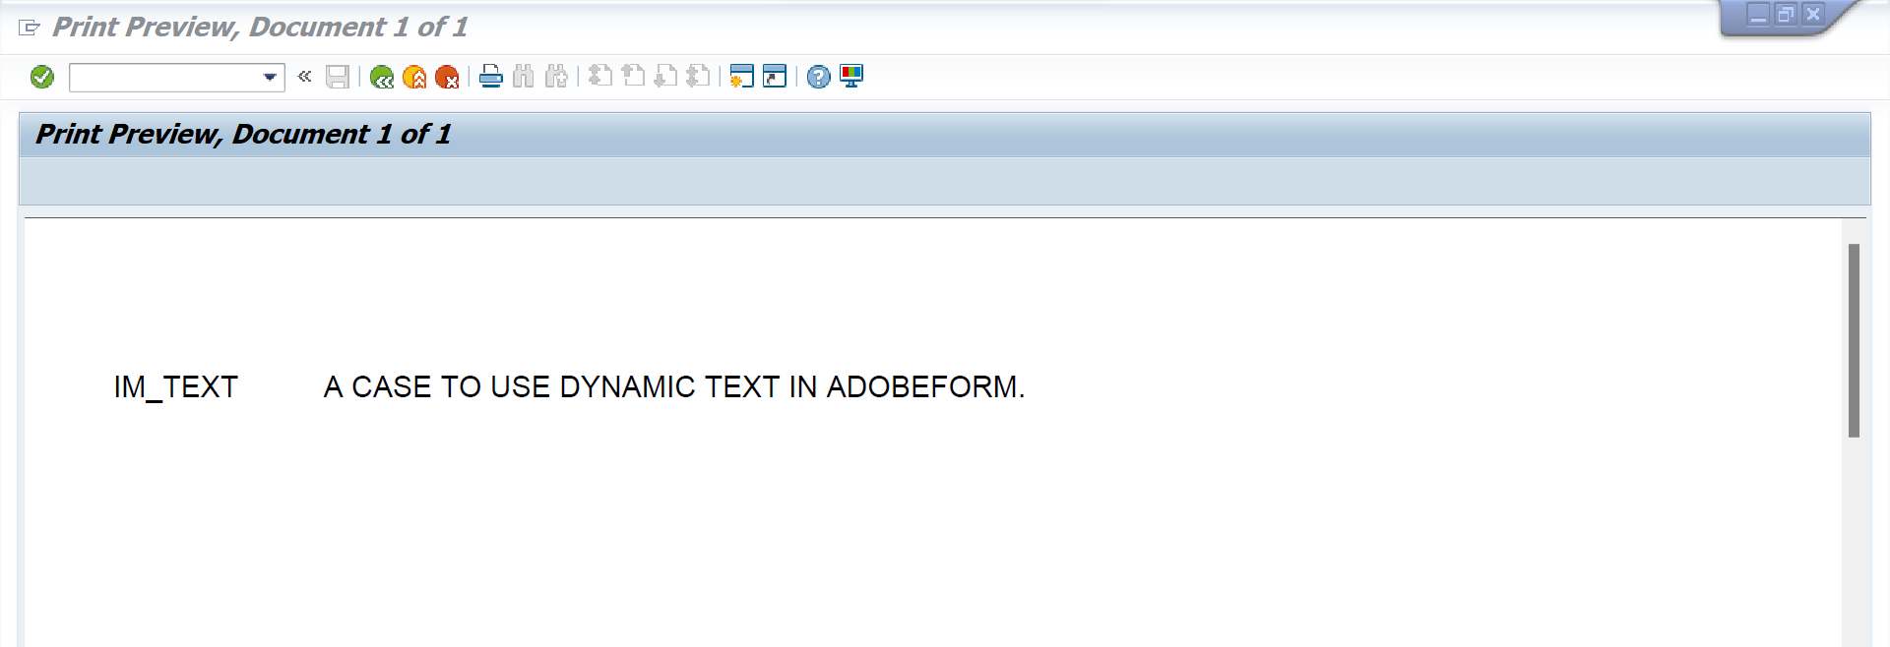

Text printing in multiple lines

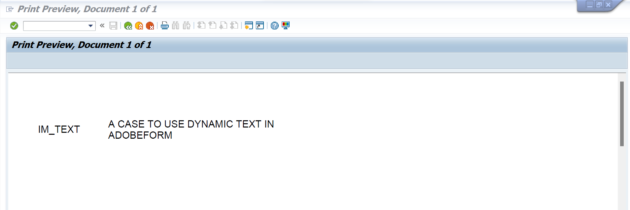

Q-5. Demonstrate a case to use INCLUDE TEXT in adobe forms.

Creating Standard Text in **SO10:**

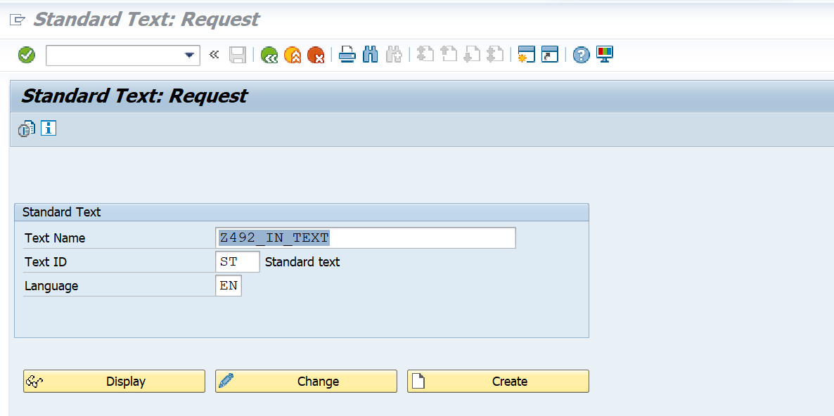

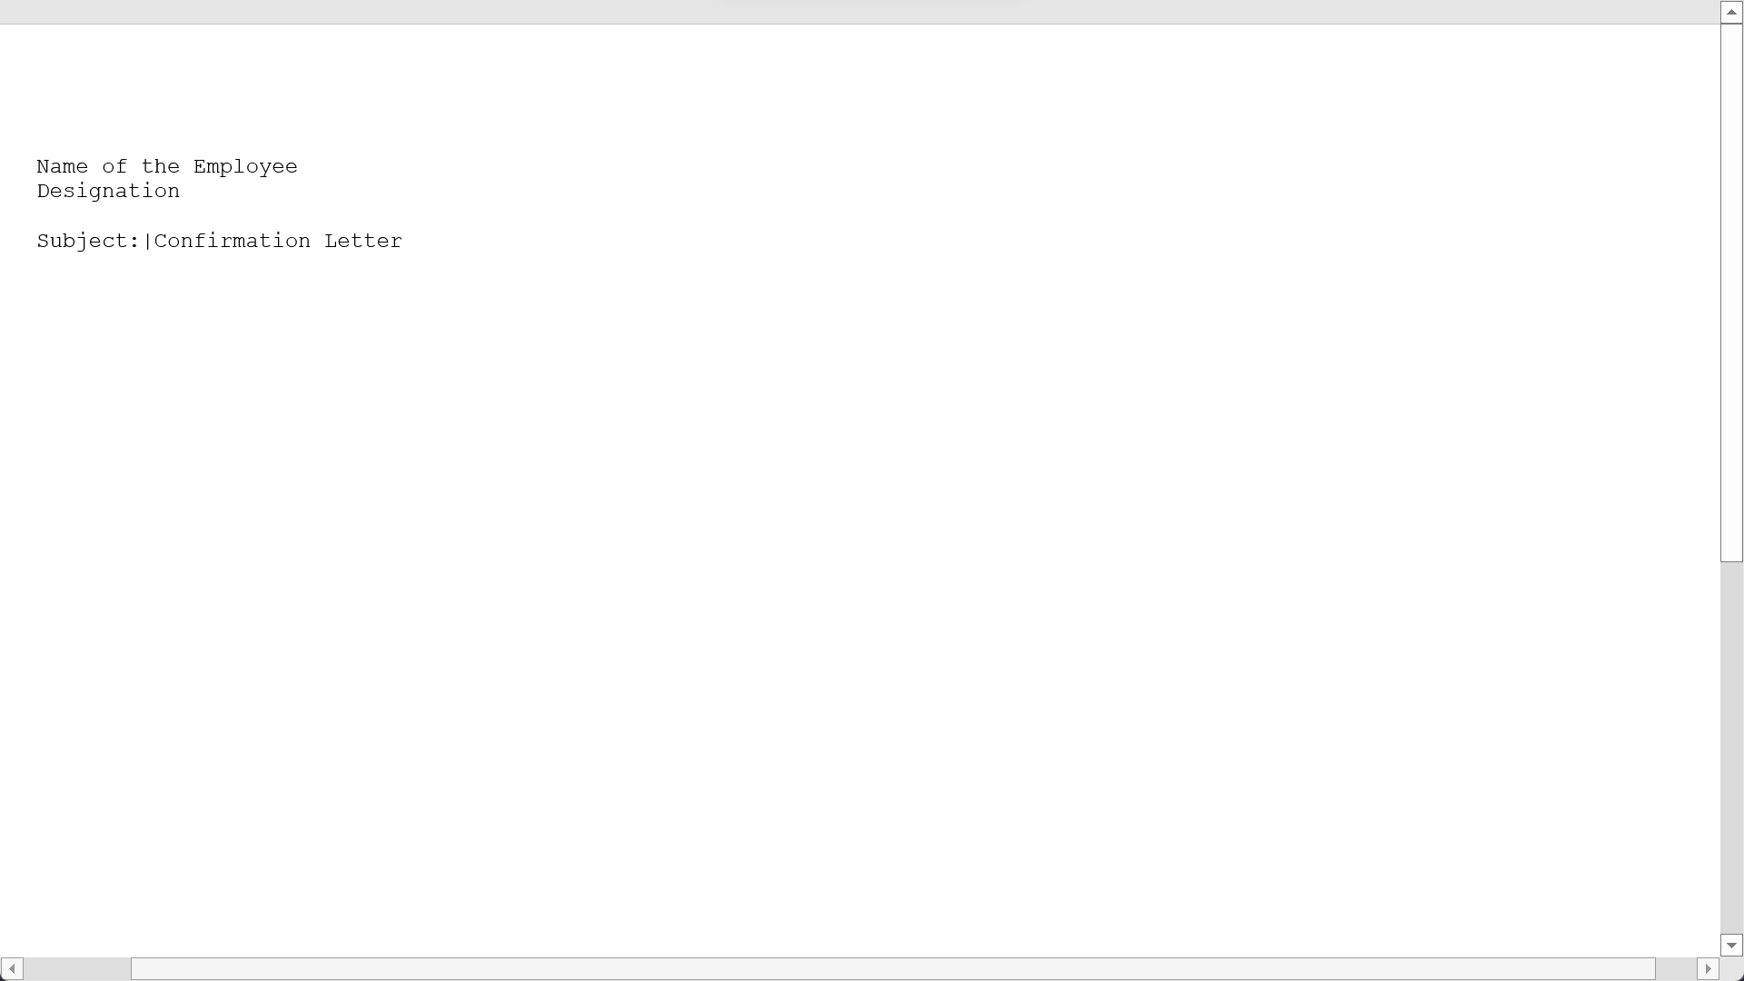

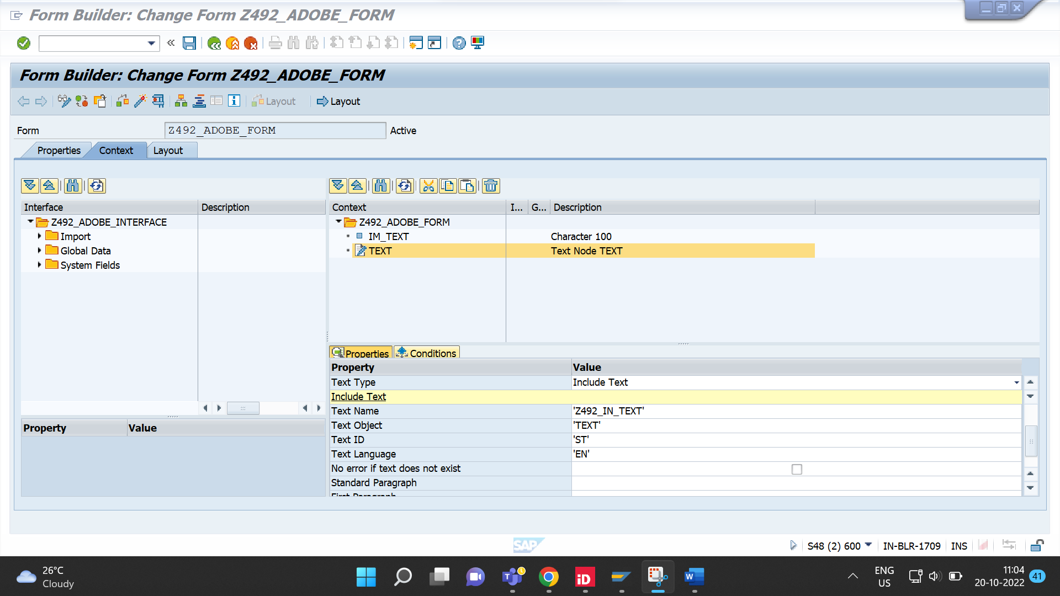

**OUTPUT:** Displaying Include Text

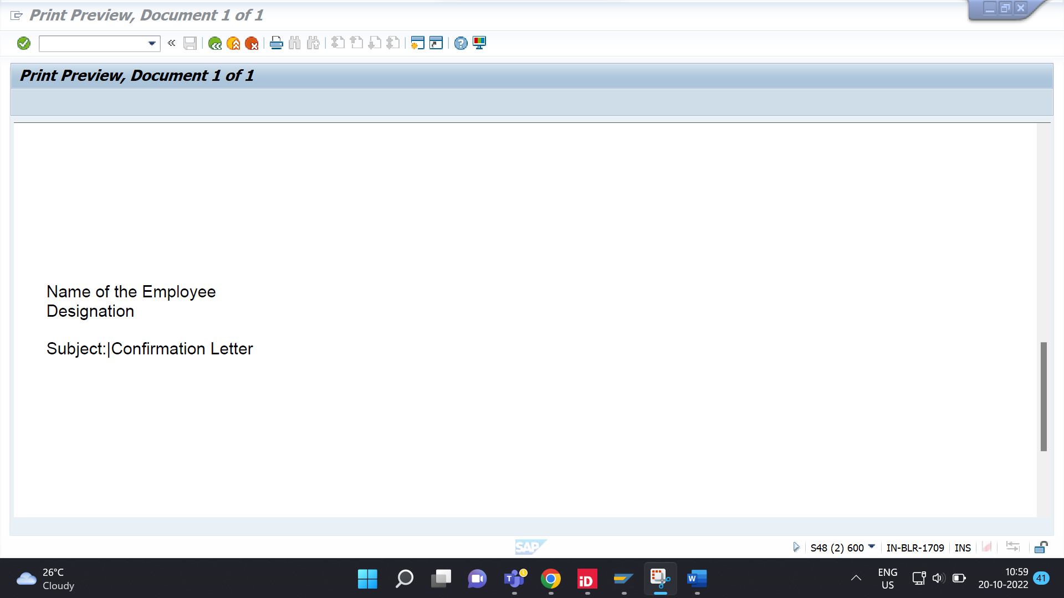

Q-6. Create a case to use image from SE78 in adobe forms.

Go to SE78: Check for image existence

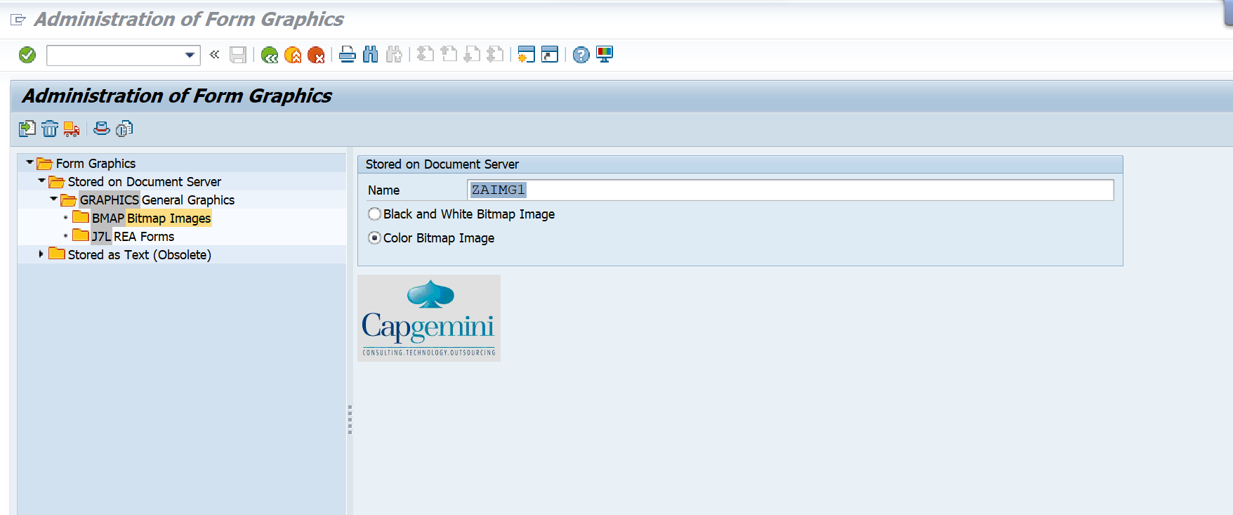

Declaration of image fields:

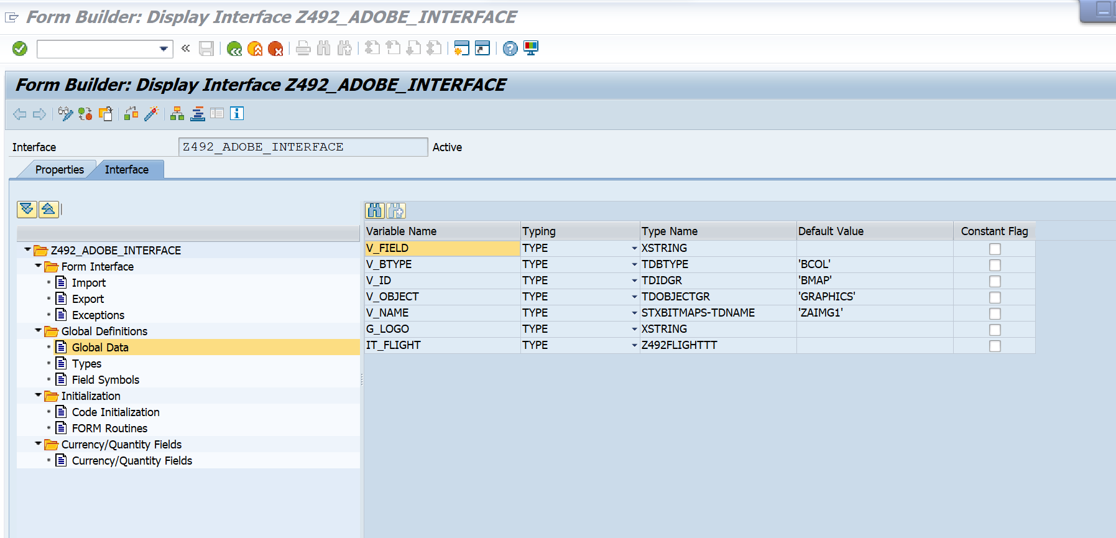

Creating the flow logic:

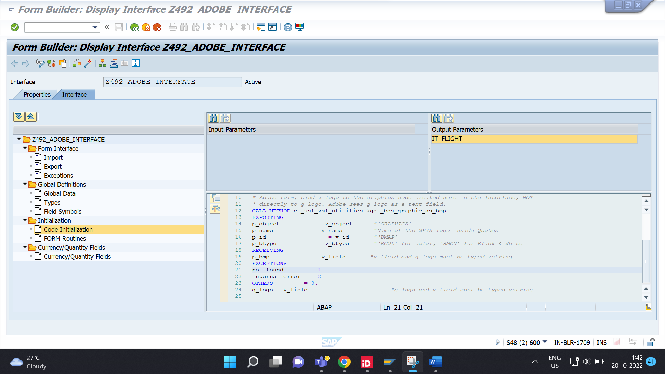



**OUTPUT:**

